**Ideation Phase**

**Define the Problem Statements**

| Date | 24 September 2022 |
| --- | --- |
| Team ID | PNT2022TMID3270 |
| Project Name | REAL-TIME RIVER WATER QUALITY MONITORING AND CONTROL SYSTEM |
| Maximum Marks | 2 Marks |

**Customer Problem Statement Template:**

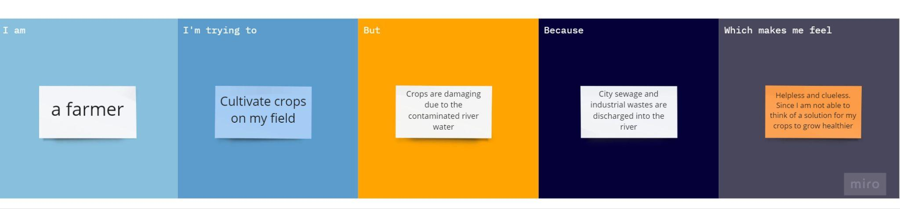

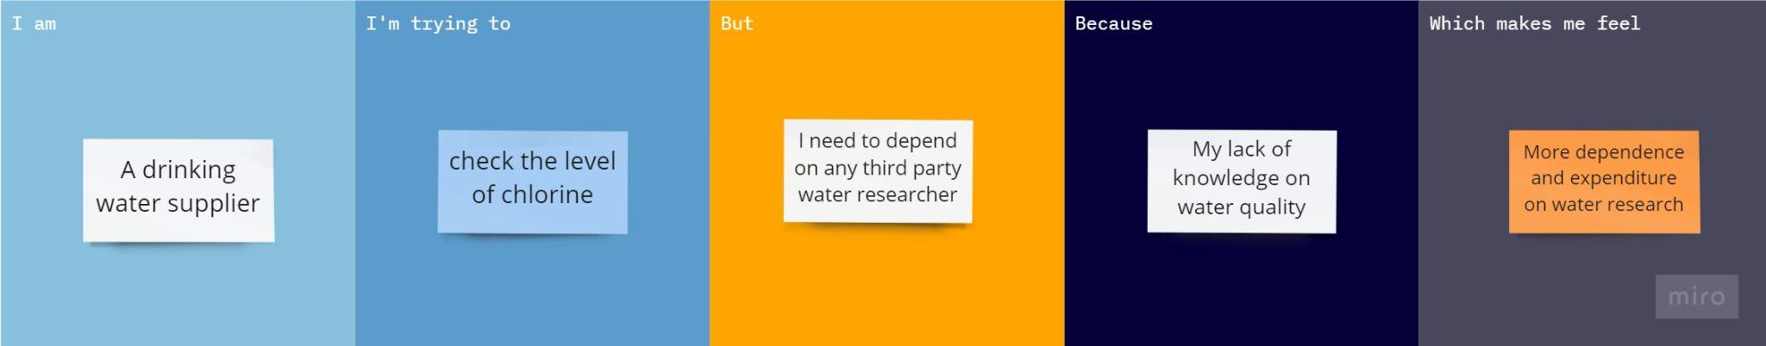

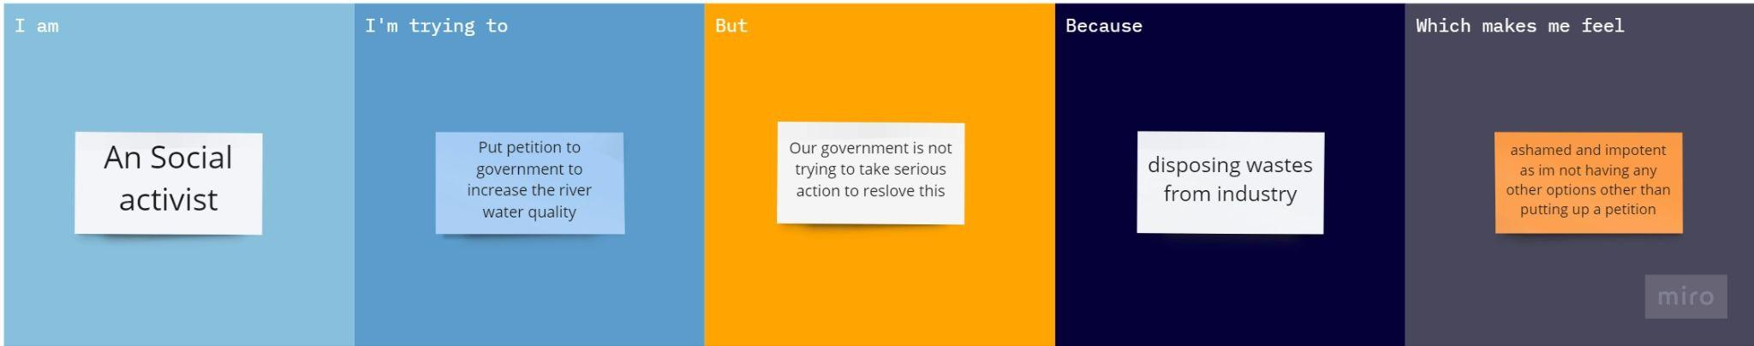

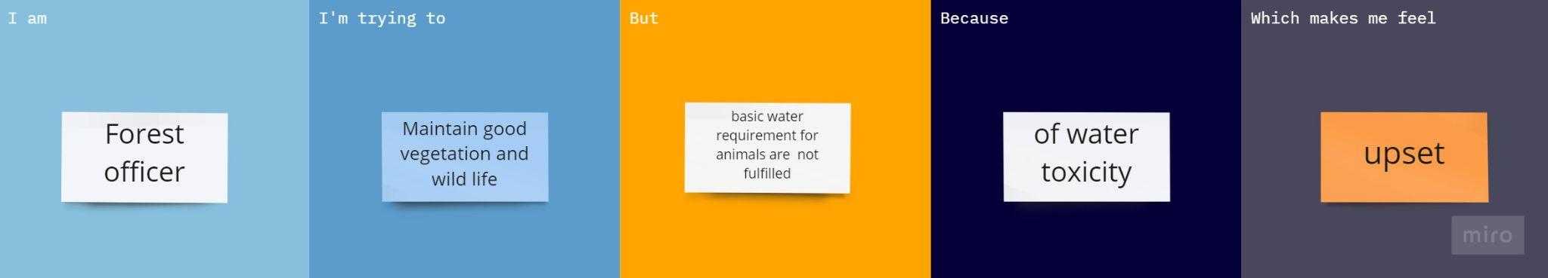

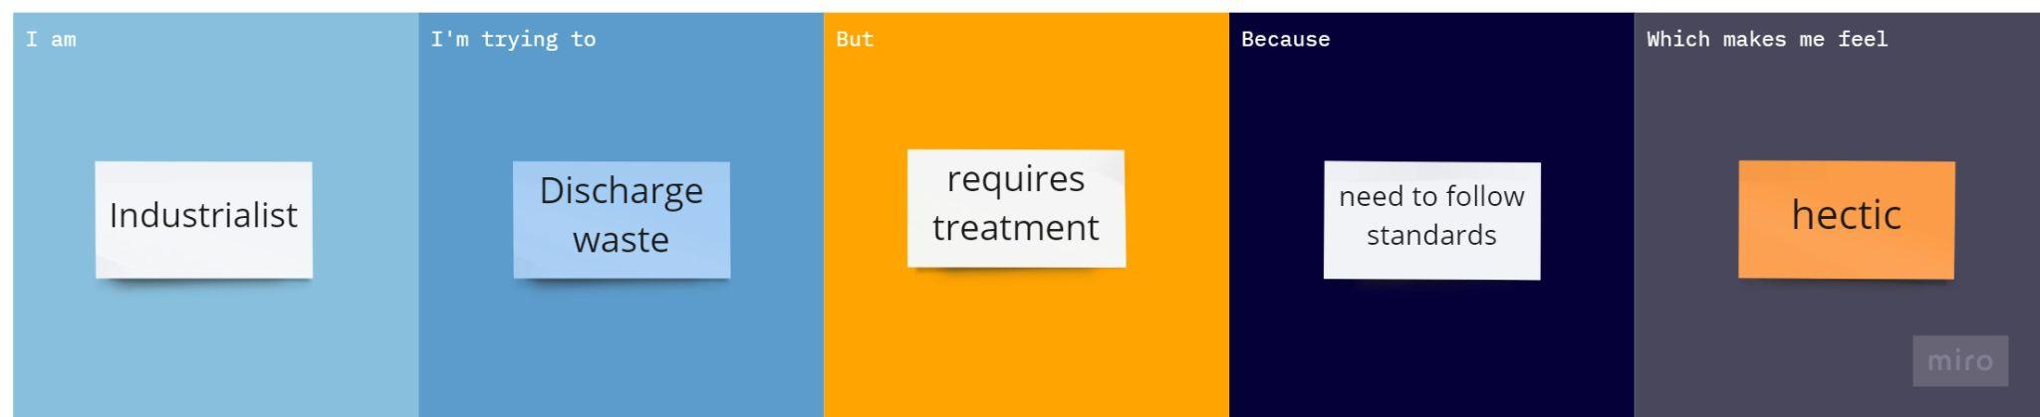

**Submitted by**

M.AARTHI

PV.ARUN PRIYARAAJ

M.DEIVANAI

M.HARRISH